Sanjoy Kumar Mallik

Hore, Somnath (Born: Chattagram (present Bangladesh), 1921 - Died: Santiniketan (West Bengal, India), 2006)

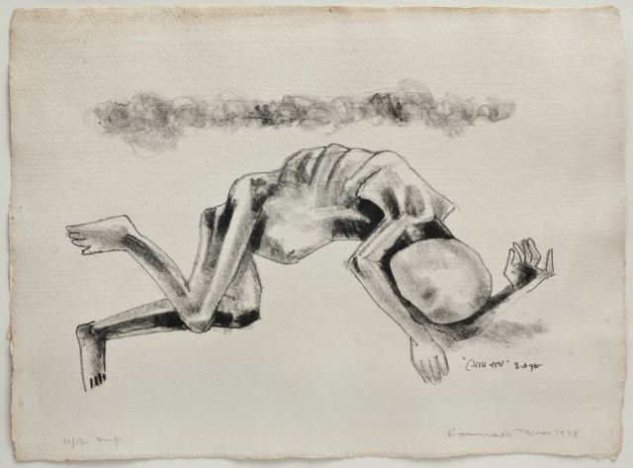 | 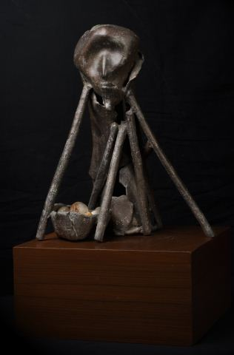 | 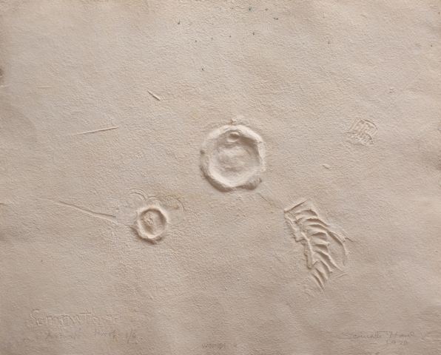

Somnath Hore (i) print (ii) sculpture (iii) pulp-paper print
(From http://www.akarprakar.com/portfolio_item/wounds/; medium-size-date not mentioned in the website; to be provided on enquiry with the Akar Prakar gallery)

Born at the beginning of the 1920s, and acquiring academic training during the mid 1940s, Somnath Hore represents a generation of artists in Bengal, India, who actively redefined the language of visual art from an earlier phase of nationalist self-redefinition, in the face of a long colonial history of British socio-political and cultural domination. In response to the imposition of an alien taste and the hegemonic proclamation of the coloniser’s perspective as superior, Indian responses of the nationalist dimension had harked back to the pre-colonial past in an attempt to invent a contemporary that would visibly retain links to ‘tradition’. The generation of artists to which Hore belongs, wanted to stand apart from both academisms, that of the British instituted art schools as well as the Indian nationalist mode. Thereby two prominent directions emerged, which were split across the debate over the primacy of pictorial style and content, though commonly open to global art influences. As part of this evolving modernism, Hore began with a strong socially-responsive thematic concern for a suffering multitude, which he subsequently modulated into a lifelong linguistic search, where the formal elements of visual language merged effectively with the thematic into a harmonious singular. Hore expressed his vision in a number of media, but above all that which was paramount within his diction was a preference for the graphic and that predilection determined his handling of each media.

While enrolled at the City College in Kolkata for a B.Sc. course in 1940, Hore came into contact with the Communist Party. The onset of World War forced him to leave for his native Chattagram, which was facing the threat of Japanese bombardment (1942). The impulse to document the ghastly devastation turned him towards visual art. Following Chittaprosad who was touring the Midnapore district documenting an infamous man-made “famine” (1943-44), Hore’s sketches recorded the suffering multitude in Chattagram; these were published in the Communist Party journals Peoples’ War and Janajuddha. Hore credits Chittaprosad as his first mentor, who led him “virtually by the hand and guided and encouraged me to draw portraits of the hungry, sick and dying people”

At the Government School of Art, Kolkata (1945) Hore developed a skilled hand for powerful drawing through Zainul Abedin. His inherent interest in the graphic relates to his admiration of an album of contemporary Chinese woodcut prints circulating among the cultural activists of the Communist Party around 1946. Hore mastered the medium from Safiuddin Ahmed. Accompanying party members to North Bengal, he produced the word-image documentation Tebhagar diary (1946) recording the sharecropper’s political struggle to claim two-thirds of their produce. Unlike the famine sketches, the Tebhaga drawings are affirmative images of determined conviction in collective endeavour. When he transferred his 1946 Tebhaga drawings to wood engravings in the 1950s, Hore had matured in his understanding of the possibilities of the printmaking medium, exploring the solid mass of black and the minimum cut-away areas of white effectively. His 1956 linocut print of the “Pavement Child” is an extension of the same. When the Party was banned (1949) he went “underground”; he finally took his diploma as an external candidate in 1957.

Pranabranjan Ray opines that a Krishna Reddy exhibition (Delhi, December 1958) initiated Hore’s attempts towards single-plate, multi-colour viscosity prints. But he carried this forward to a wider significance, when the acid erosion of the metal plate translated into a leitmotif of ‘wounds’. From the 1958 etching print titled “Children” to the 1959 colour intaglio “Genesis”, the defining of tonal planes through linear texture transformed into acid-bitten textural roughness and a non-angular lyricism of lines. It was but a step from here towards the equation of process with idea; the acid bath “bite” with the recurrent metaphor of the “wounds”, the further extension of which manifested in the pulp print medium, where the clay or wax matrix on which the initial marks were made literally became the body on which the scars were inflicted through the process of image-making. Thus the multiple original of printmaking merged with the sculptural in rendering, fusing the expressive possibilities of one medium with that of another. In the 1970s, Hore evolved the distinctive paper-pulp print series, the Wounds, where scars inflicted through the process of image-making brought the relief object to a cross between printmaking and sculpture.

Thereafter, when his sculptural interest took to the medium of bronze-cast objects, the now-lost 1977 memorial to the 1975 Vietnam war, a 40 inch high 40 kg bronze image of a mother clutching on to her child became a major statement. Hore concentrated on sculpture in bronze from 1983. Working with sheets of wax, torn, cut and re-attached, each act of a cut or gash as an integral part of the image-making procedure emerged into a metaphoric comment of a larger dimension, that of violence and mutilation, and the persistence of scars in social experience.

Nearly two decades later his 1995 Draupadi Holding Abhimanyu, a bronze sculpture alluding to the epic narrative Mahabharata, recalls Michelangelo's Rondanini Pieta, not in its stylistic affinity but the spirit of its theme of a mother holding onto the limp body of her son. In sculptures such as these, Somnath Hore reduced human anatomy to the barest, simplest essential of the folded sheets of wax-cast metal and thin cylindrical units (that doubled up as channels for the molten metal to pass through during the process of casting) for the limbs.

Possessing a versatile range in his choice of media for artistic self-expression, Hore traversed effortlessly in drawing, prints, metal sculpture as well as oil paintings, where the medium was flexibly moulded to the necessities of the image potential. As an example of the early modernist aspirations from India, Hore explored a diverse variety of media where formal experiments were always guided by the expressive necessities of the image.

Despite the haunting sight of an anguished struggle, Hore’s sculptures, prints and paintings exude a sustained feeling of endurance and hopeful regeneration, whereby all is not altogether bleak. The battered bodies are almost blasted open, but the forms continue to communicate a degree of resilience. He refused to let the wounds in his memory heal; he refused to allow the viewer to lapse into unproblematic complacence. His statements are positioned between a near-factual utterance of inflicted suffering, and optimism for deliverance; the more they make the viewer aware of the wound, the more they inspire a will to persevere and overcome.

References and further reading:
K.G. Subramanyan, (1986), “The vision of Somnath Hore”, in Visions, exhibition catalogue, Birla Academy of Art and Culture, Calcutta

Somnath Hore, (1992), in Wounds, exhibition catalogue, Seagull Foundation for the Arts, Calcutta

Somnath Hore, ‘Chittaprosad — the humanist’, in Chittaprosad, Lalit Kala Akademi, New Delhi, 1993

Pranabranjan Ray, (November 1995) “Hunger and the Painter: Somnath Hore and the Wounds”, in Somnath Hore/Bronzes, exhibition catalogue, CIMA Gallery, Calcutta

R. Siva Kumar, (November 1995), “Somnath Hore: Images of Discontent”, in Somnath Hore/ Bronzes, exhibition catalogue, CIMA Gallery, Calcutta

Sanjoy Kumar Mallik (co-authored), (January 2002), “Somnath Hore: a focus”, in Lalit Kala Contemporary No. 45 (Ed. Amit Mukhopadhyay), Lalit Kala Akademy, New Delhi

List of Works:
1. Peasant’s meeting, 1951, wood engraving, 13.75 X 18 cm
2. The False Prophet, 1964, colour etching, 25 X 38 cm
3. The Princess, 1961, etching, 10 X 13 cm
4. Wound 20, 1972, pulp-print, 51 X 64 cm
5. Wound 49, 1979, pulp-print, 51 X 64 cm
6. Untitled mural on south wall of mural studio in Kala Bhavana, Santiniketan, 1970-73 & 1977, brush drawing on lime mortar with embedded objects, 322 X 555 cm
7. Untitled mural on outer north wall of old Nandan building/present Graphics studio in Kala Bhavana, Santiniketan, dated 26.11.77 & 24.2.82, tesserae mosaic, in two parts 231 X 166 cm & 240 X 286 cm
8. Compassion – Draupadi holds Abhimanyu, 1989, bronze, 7 X 19 X 40 cm
9. Old man, 1993, bronze, 9.5 X 16 X 14 cm
10. Draupadi of Mahbharata, 1993, 35 X 82 X 42 cm

[For examples 1 – 5 refer undated monograph on the artist from the Lalit Kala Akademi, New Delhi; for 6 & 7 refer The Santiniketan murals, Seagull Books, Calcutta 1995; for 8 – 10 refer Somnath Hore/Bronzes, CIMA Gallery, Calcutta 1995]

